Business Process Guide

Recruiting Solutions:

Hiring Manager

Manage Job Openings and Applicants

06/23/2015

Table of Contents
Double Click Here to Change Text
Table of Contents i
Process Overview 1
Where the Data for This Process Comes From 2
Where the Data from This Process Goes 2
Related Information 3
Prerequisites and Assumptions 3
Helpful Hints 3
Key Definitions 3
1.0 Recruiting Home 4
1.1 Features and Functionality 4
1.2 Analytics 6
2.0 View and Manage Job Opening 16
2.1 Search Job Openings Process Steps 17
2.2 Understanding the Manage Job Opening Page 19
2.3 Job Opening Requirements 21
3.0 Tracking Applicant Dispositions 22
Flow Diagram of Basic Procedure 22
3.1 Applicant Disposition Requirements 23
3.2 Hiring Manager Responsibilities 27
3.3 Applicant Actions 33
3.4 Group Actions 38
4.0 Create and Manage Applicant List 39
Expected Outcomes 43

Process Overview
Manage Job Openings and Applicants is the process in which recruiters and hiring authorities review and determine qualified applicants, track applicant dispositions, and update applicant or job opening information after receiving application materials and prior to making an offer and finalizing a hire.

This is a shared process between Recruiters and Hiring Managers. This Business Process Guide provides the guidelines for a hiring manager to manage their applicants and job openings.

Where the Data for This Process Comes From
The data from this process comes from Job Openings (RS: Create a Job Opening) and applicants who apply to vacancies at the University of Minnesota (RS: Search and Apply).

Where the Data from This Process Goes
Applicants who are hired into job openings flow to RS: Offer and Prepare for Hire, and to HR: Manage Workforce.

Related Information

Prerequisites and Assumptions
Before you can perform the Manage Applicants and Job Opening process, it is either required or assumed that each of the following conditions has been met:
Prerequisites and Assumptions
Prerequisite/Assumption | Detail
Knowledge of University Policy and Procedure
Knowledge of Bargaining Unit contracts
Knowledge of employment rules

Helpful Hints
- The Recruiting Home displays various pagelets that together provide a dashboard view of recruiting activities. All recruiting actions can be accessed from this page.
- If you are lost in navigation, click Recruiting Home at the top of all Recruiting Pages.

Key Definitions
Key Definitions
Term/Acronym | Definition
EOAA | Equal Opportunity and Affirmative Action
CS/LR | Civil Service/Labor Represented
P&A | Academic Professional and Academic
OFCCP | Office of Federal Contract Compliance Programs

Recruiting Home
Recruiting activities are performed by navigating to the Recruiting Home page. Hiring Managers and Recruiters use this page to access and manage their day-to-day recruiting tasks. The dashboard provides an easy way to navigate into the functions that Hiring Managers and Recruiters need to perform their tasks.

Search Committee members will also be able to navigate to the Recruiting Home, in order to view the applicants and job openings for which they have search committee responsibilities.

1.1 Features and Functionality
Navigation to the Recruiting Home is:

Main Menu > Recruiting > Recruiting Home
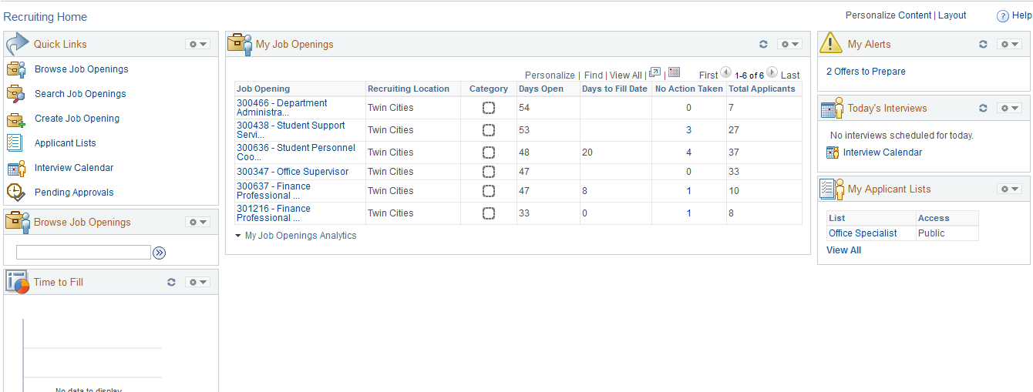
The Recruiting Home displays various pagelets that provide a dashboard view of recruiting activities and functions. all Recruiting roles have access to features and functions except where noted. We have highlighted the features, from Left to Right, and will give a brief explanation of each one.

1. The Quick Link pagelet is easy access to the Recruiting menu items that you have access to.

2. My Job Openings, by default, displays the jobs for which you have primary responsibility. You can personalize the setting to include all jobs that you are associated with by clicking on the settings icon and selecting “Jobs Associated with Me”.
Job Opening analytics are available from the My Job Openings pagelet. Users can click on this link to view graphs on Aging Analysis and Open and Close Trend.

3. My Alerts displays new information pertinent to your work. Your role will determine which alerts are displayed.

4. Browse Job Openings is a quick way for you to drill in to view your open jos.

5. Time to Fill displays once you have started to fill your job openings. You will always be able to see what your current time to fill statistics are!

6. Today’s Interviews will display interviews for you, as long as the interview was scheduled in the Recruiting module.

7. My Applicant Lists displays private and public applicant lists. If you are a Recruiter or Hiring Manager, you can use the Applicant Lists functionality to save applicants that you want quick reference to. Applicants can be added to a list and you can perform tasks for one, several, or all applicants on the list at the same time.

All pagelets on the dashboard can be personalized, and you can also drag and drop the pagelets on the page to fit your work style.

One thing to note about the Recruiting module is that the navigation through the system does not behave like the rest of the system. Most activity in HRMS will be driven through the Menu; Recruiting activities are not. Many activities that you perform will take you to “hidden pages” that do not follow breadcrumb navigation. To go back to where you navigated from, you will always want to click on “Return”.

1.2 Analytics
The Recruiting Home delivers many analytics that can be useful in gauging the effectiveness of Recruiting efforts.

My Job Opening Analytics
Job Opening analytics are useful to see what is happening with your jobs. All Recruiting Users will have access to these analytics.

Click on My Job Openings Analytics

Click on the My Job Openings Analytics on the My Job Openings pagelet.
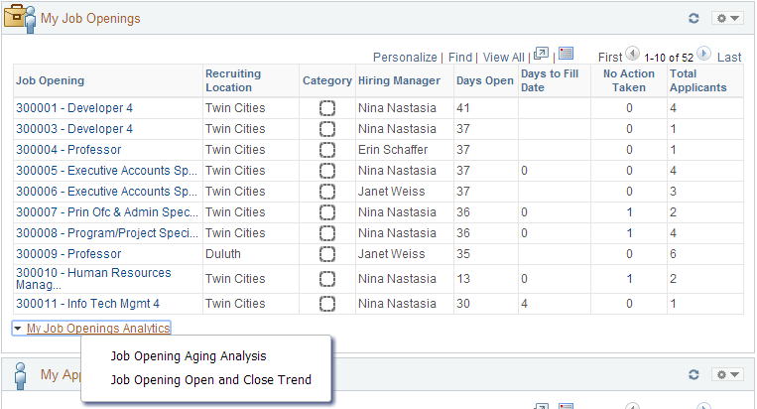
You will have two pivot grids available to view. Let’s look at the Aging Analysis first.

Job Opening Aging Analysis:
Click on Job Opening Aging Analysis to view the chart.
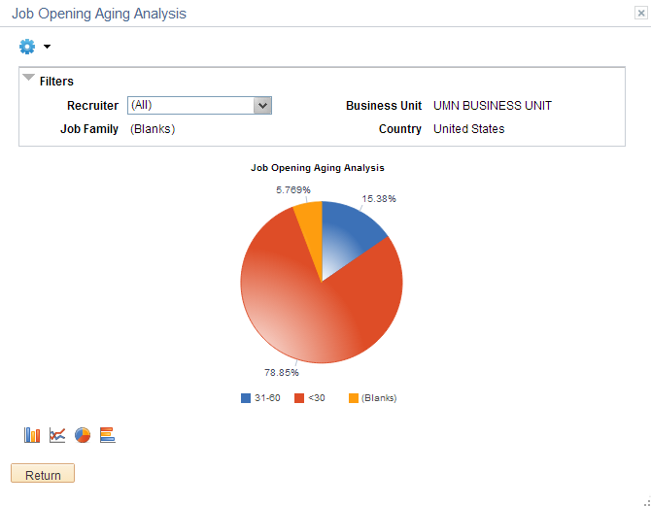
This chart will show you how long your jobs have been open. This chart will show all jobs that you are able to access in your role.

If you hover over an area of the pie chart, you will see how many jobs meet that criteria:
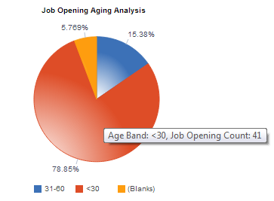

You can click on any area of the chart to see a detailed view (a list of data) or to drilldown further into the data.
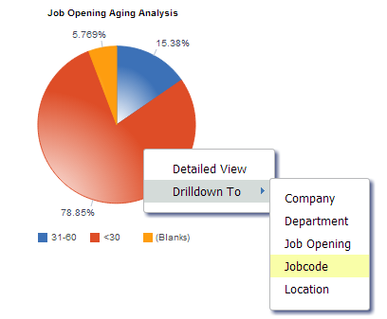
When we click on Jobcode, we will see all of the jobs that are open for less than 30 days, broken down by job code:
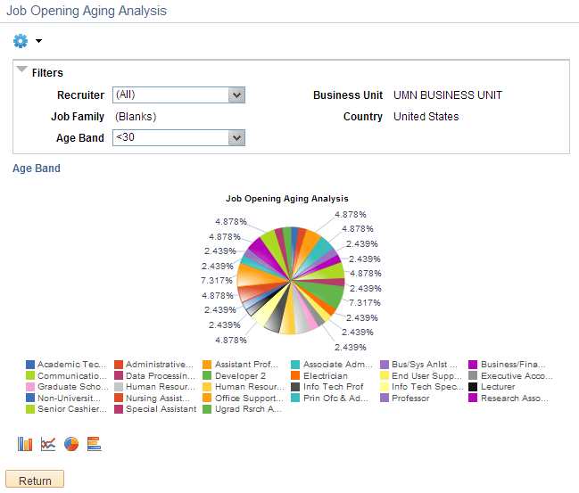

You can continue to drill into the data, in order to see how your jobs are performing. Clicking on “Age Band” will take you back to your original chart.
On all delivered analytics, you can also view and export the data, as well as change the options of the chart by clicking on the Settings Icon.
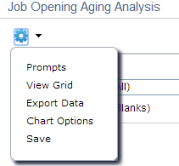

Job Opening Open and Close Trend
This chart shows you how many jobs have been opened and closed on a monthly basis. Click on the Job Opening Open and Close Trend link to view the chart.
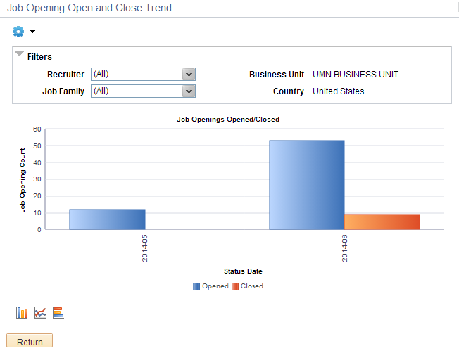
As with the Aging Analysis chart, you can further drill in to view information about the openings. You can also click on the chart options above the Return button to change the type of chart. In this example, we have changed the chart to a horizontal bar chart:
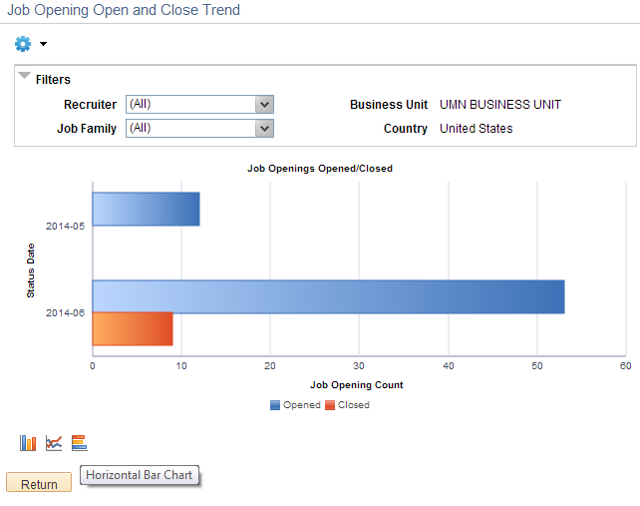
To view a detailed view, click on any area and select Detailed View:
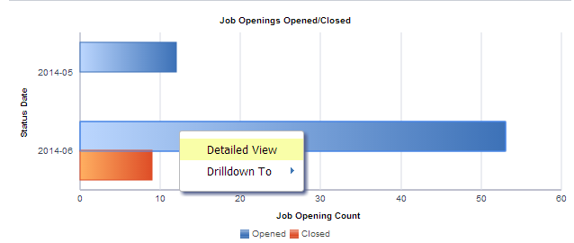

The detailed view, available on all analytics, is simply the data that populates the charts. You can download the data to Excel in order to create your own metrics, if you would like.
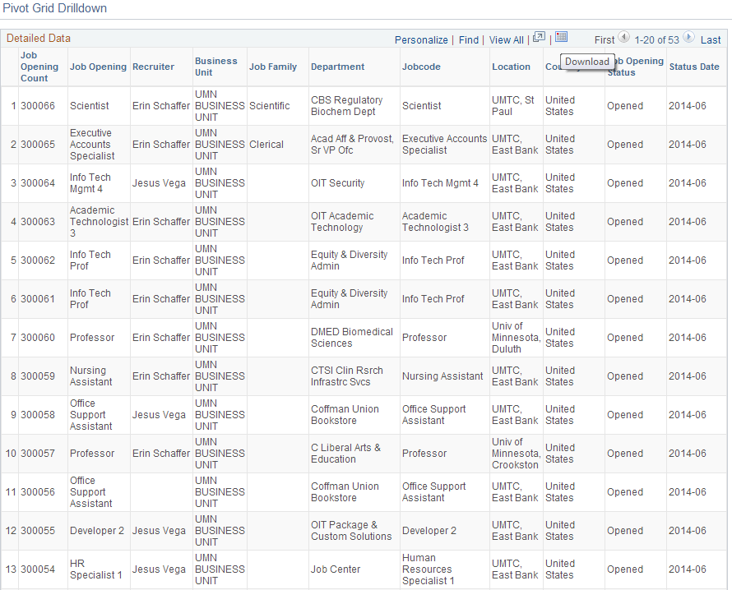

Time to Fill Analytics
The Time to Fill pagelet provides Recruiters and Hiring Managers with up to date information about the time it takes to fill their postings.
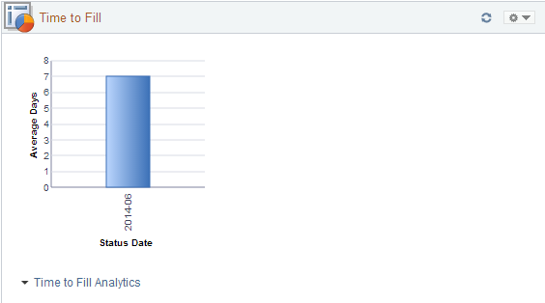
As jobs are opened and filled, this grid is dynamically populated. In this example, it is taking us an average of 7 days to fill a job opening. Hovering over this chart will show you the information:
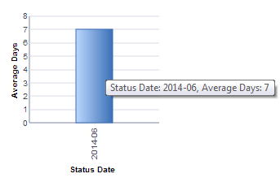
You can view the time to fill chart as a pivot grid by clicking on Time to Fill Analytics, and then clicking on Time to Fill
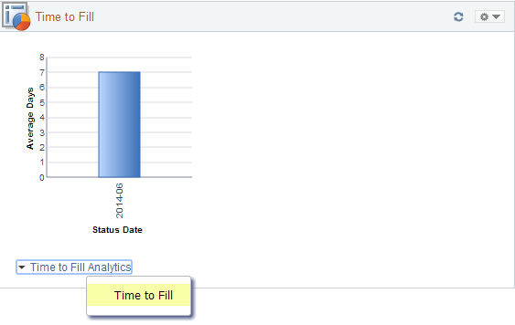
This will open up the chart in a new page, and allow you to further drill in to the data, as you did with Job Opening analytics.

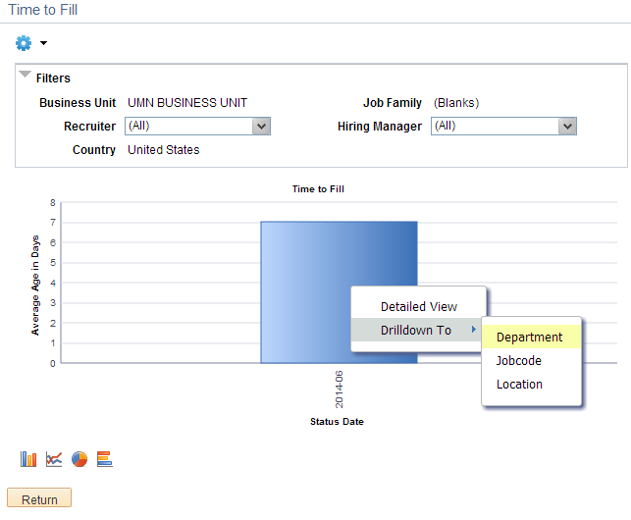
If we click on the chart, we get the option for a detailed view or to drilldown.

In this example, we will drill down to Department to see how our departments compare:
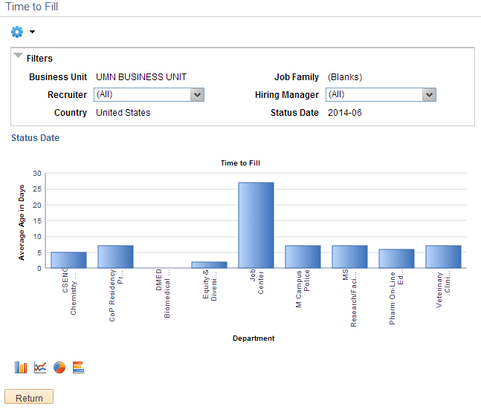

2.0 View and Manage Job Opening
Job Openings are the primary mechanism for Hiring Managers to access information about applicants and the job opening itself.

You can view your job openings from the My Job Opening pagelet, or by searching job openings through Recruiting Quick Links.
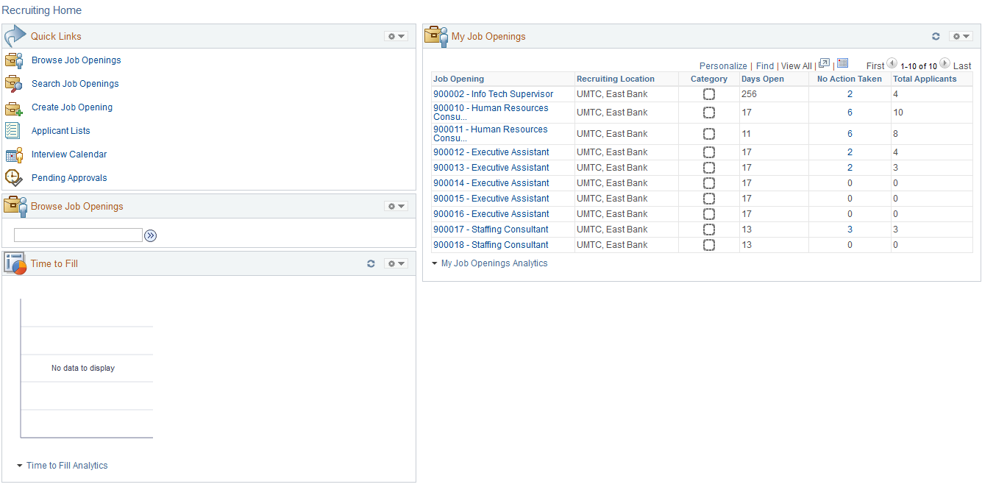

You will only be able to return search results for job openings in which they are part of the Hiring Team.

2.1 Search Job Openings Process Steps
Step 1: Click Search Job Openings link

The Search Job Openings page displays
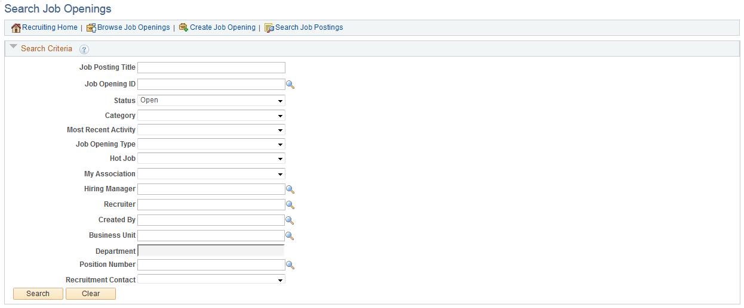

Step 2: Enter Search Criteria and Search openings

You can search by a wide variety of criteria.

Status: Canceled, Denied, Draft, Filled, Hold, Open, Pending
Most Recent Activity: Active within Last 2 weeks, Last 3 days, Last Month, Last Week, Last Year, Today, View All, Yesterday
Job Opening Type: Continuous, Standard
My Association: All Jobs, Jobs Assigned to Me, Jobs Associated with Me, Jobs Created by Me

As well as searching by Hiring Manager, Recruiter, Created by, Business Unit, Department, and Position Number!

The fewer criteria you enter, the more results you will receive.

In this example, we will only search for Open jobs. Select the criteria and click Search.

Step 3: View Search Results

The search returns only those jobs that you have an association with. You can click on any of the links to go to the Manage Job Openings page.

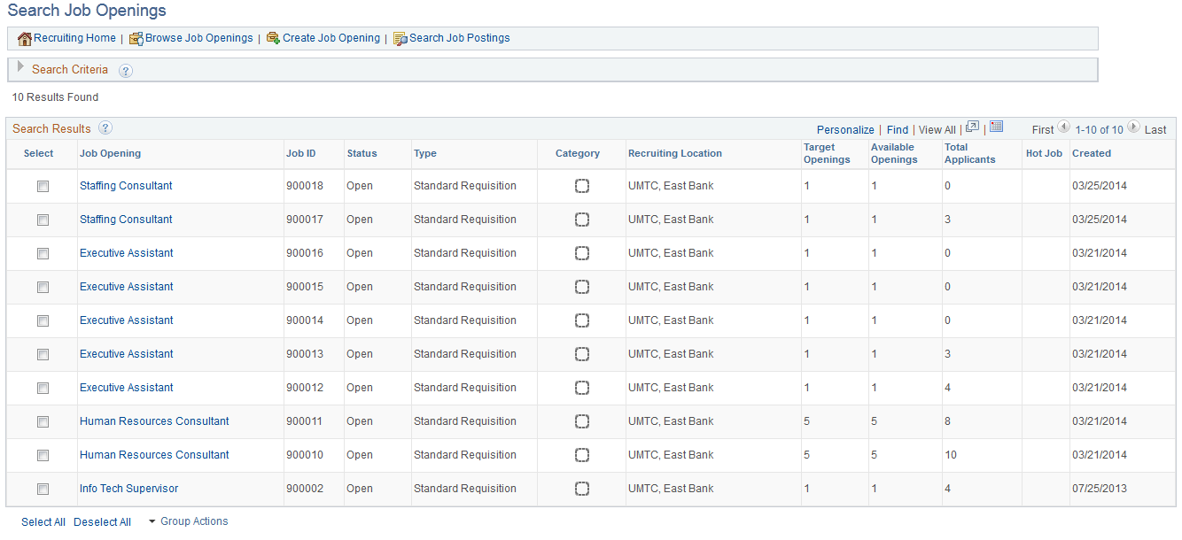

2.2 Understanding the Manage Job Opening Page
The Manage Job Opening page is the primary page for most Recruiting activity. This page is made up of four different tabs, though we are not using the Applicant Screening tab at this time.

Applicants Tab:

The applicant tab contains all applicants who have applied for the position, and allows for you to take action on applicants in certain stages. Hiring Managers have more restricted access than Recruiters.

Below is the Hiring Manager view of the applicant tab.

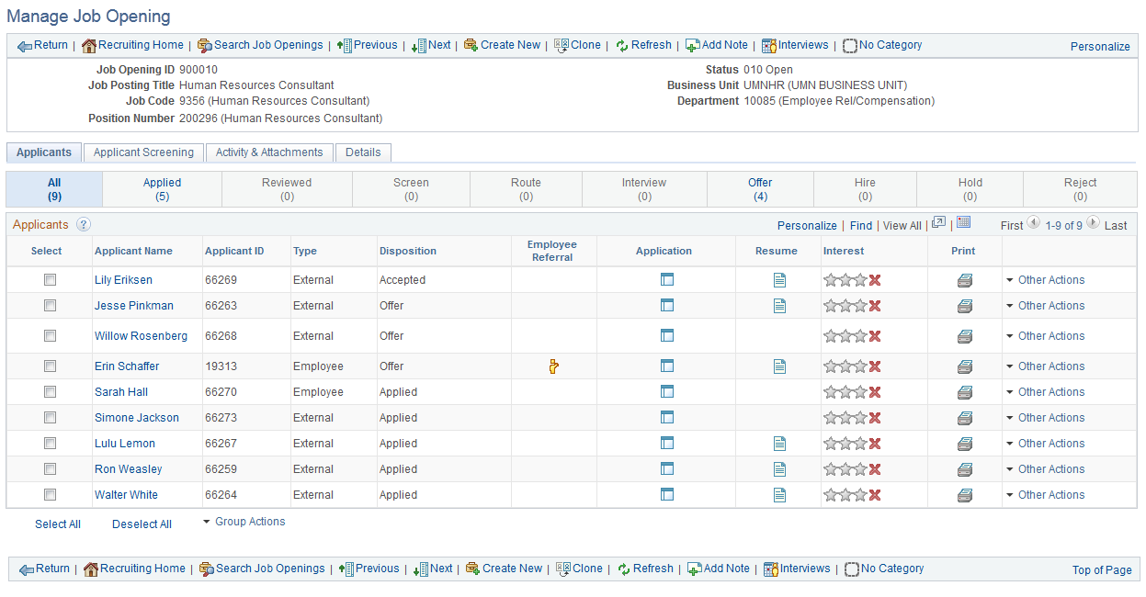

Hiring Managers can view applicants in all stages, but can not take action on applicants until they are in the disposition of Route. We will discuss this further in Tracking Applicant Statuses.

You can click on any of the status tabs to view applicants who are in a particular disposition.

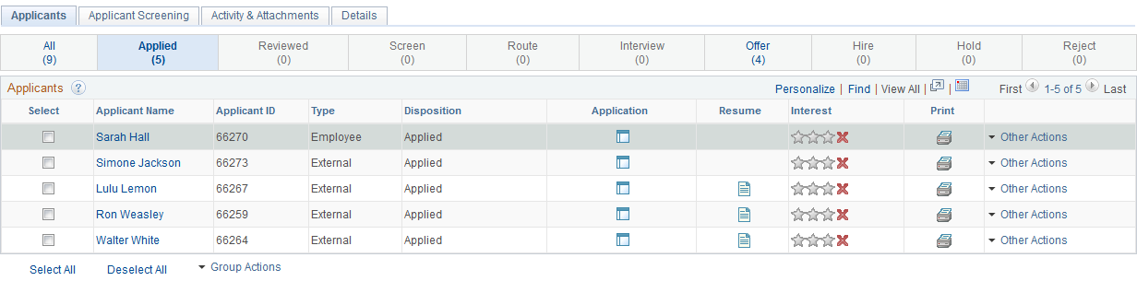

Activity & Attachments Tab

The Activity & Attachments tab allows you to view the Job History, any searches related to the job opening, add notes, add attachments, and add expenses.

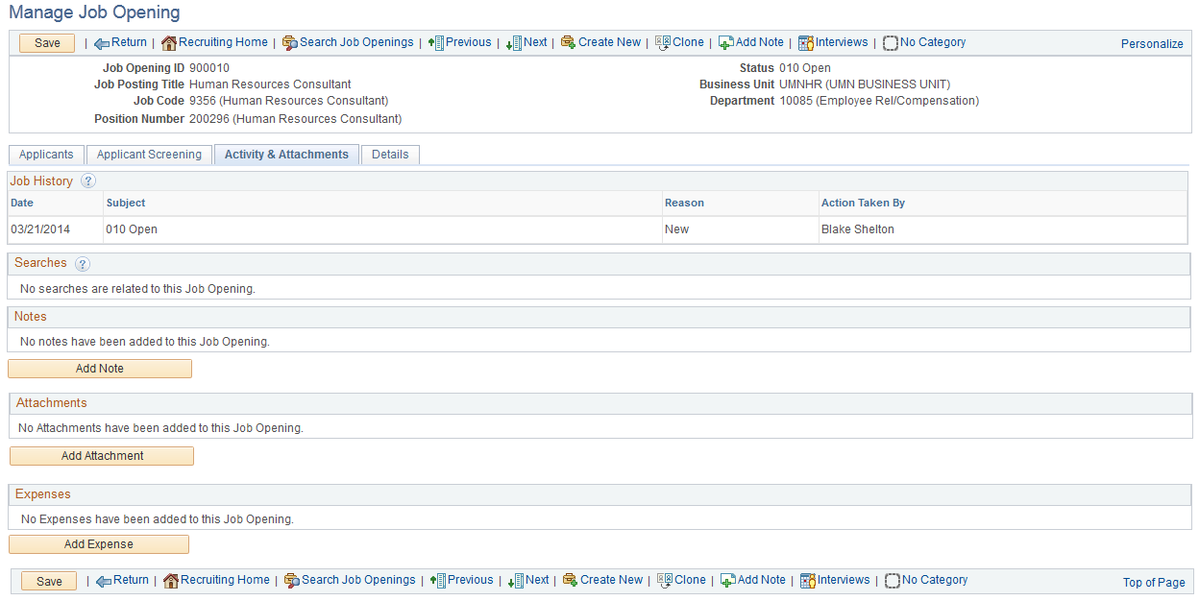

We will discuss this tab in greater detail in Job Opening Requirements.

Details Tab
The Details tab is the job opening information that was originally entered and posted to the employment site.

The Details page contains Job Details, Job Posting, Screening, and Hiring Team information.

2.3 Job Opening Requirements
The Office of Human Resources has developed a Hiring Service Agreement and Process that outlines the activities that are essential to the hiring process. Many of the activities performed happen outside the system.

Our record retention policy for all job opening and applicant information is 7 years. We can utilize functionality in the system to help retain this information.

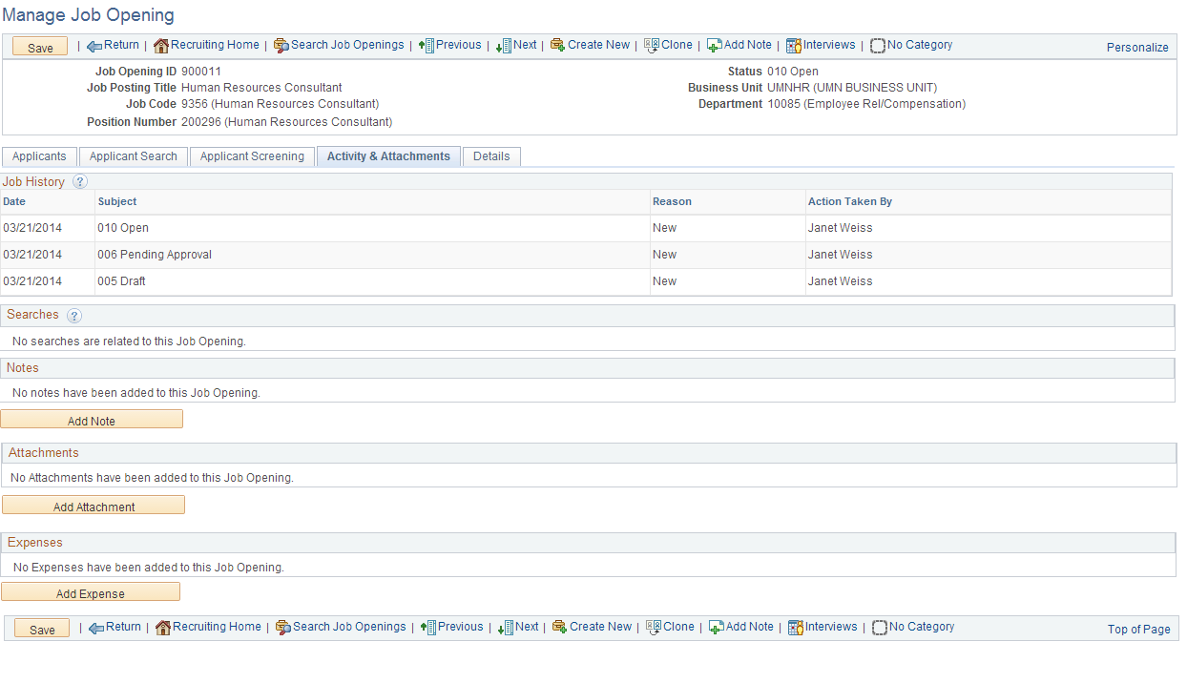
Manage Job Opening has an Activity & Attachments tab that allows us to capture information related to this specific opening.

Information that should be attached on this page includes:
- Hiring Service Agreement
- Search notes and documentation
- Recruiting strategies
- Applicant evaluations
- Notes to capture pool information related to diversity goals and availability

3.0 Tracking Applicant Dispositions
Once an applicant applies to a job opening at the University of Minnesota, it is expected that we track them through the steps of the Recruiting process. For most of our employee groups, we are required to provide information to the OFCCP yearly. Recruiting is set up so that both recruiters and hiring managers can easily move their applicants through the system, for both federal compliance and overall ease of use.

Flow Diagram of Basic Procedure
This is the overall applicant flow through the Recruiting cycle:
UPDATE: Hiring Manager does NOT have access to perform ‘Prepare for Hire’.
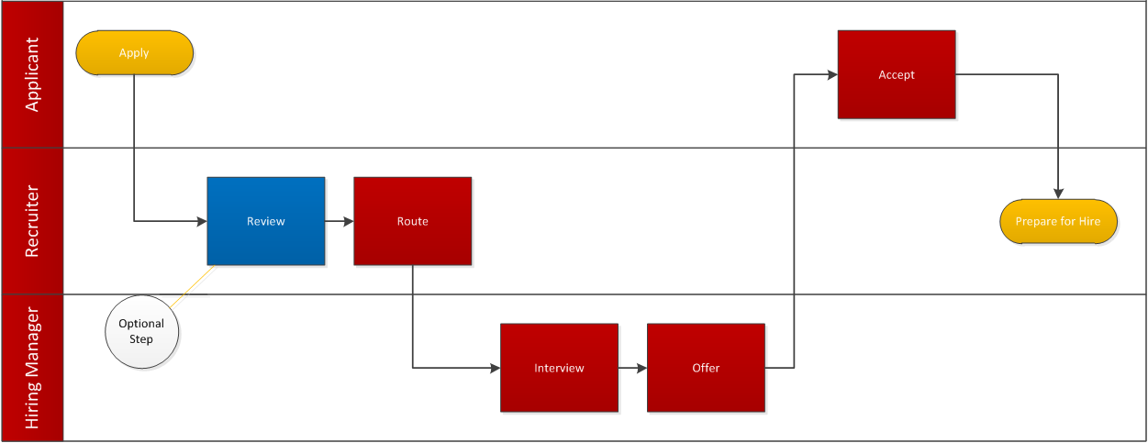
Users with Recruiter roles are responsible for the initial routing of applicant materials to the hiring manager. The system dispositions are:
Review
Route
Interview
Offer/Accept Offer
Ready for Hire
We are required to report to the OFCCP on qualified (Routed) applicants who reach the stages of Interview, Offer, and Hire for our Labor Represented, Civil Service, Academic P&A, and Faculty positions.

This process will outline the steps in the system for moving applicants through to different dispositions. Applicant dispositions should be updated real time. There are differences in when this happens or who does the work, depending on the type of job opening.

- Civil Service and Labor Represented openings require someone in a central HR office (Job Center, Academic Health Center, or UMD HR) to review the qualifications of an applicant and Route qualified applicants to the hiring manager for review.

- Most P&A and Faculty searches have a search committee that does the initial review and lets a recruiter know which candidates are qualified and should be Routed in the system. Rejected applicants must be rejected

- Student employment does not require that we route any candidates through the system, but at a minimum, a Recruiter will need to move the hired candidate through to “Prepare Offer”.

3.1 Applicant Disposition Requirements
The information provided explains changing the disposition of an applicant on a job opening as you move through the Recruiting process. Some dispositions are triggered by system actions, but this table provides the information necessary to fulfill our reporting requirements. Questions or charges by the Department of Labor, Department of Human Rights, or other agencies may be directed to you, so it is important to have the disposition of each applicant accurately documented.

Best practice is to update Applicant Disposition in real time.

Applicant Dispositions | Decision | Action | Reason
Applied | Applicant does not meet Qualifications | Change disposition to 110 Reject and determine appropriate Reason | Lacks Minimum Requirements
 | Applicant meets Qualifications | Change disposition to 050 Route*
Route | Applicant does not meet selection criteria  Applicant meets selection criteria, but will not be interviewed | Change disposition to 110 Reject and determine appropriate Reason | Lacks Selection Criteria  Misrepresentation  No Longer Interested  No Show/Cancelled Interview  Selected for Other Position  Unable to Contact
 | Applicant meets selection criteria and will be interviewed | Change disposition to 060 Interview**

* Disposition will automatically update to Route if Recruiter uses Route button or the group action to Route applicant.
** Disposition will automatically update to Interview if Recruiter uses Manage Interview functionality.

Applicant Dispositions | Decision | Action | Reason
Interview | Applicant was interviewed, will not be hired | Change disposition to 110 Reject and determine appropriate Reason | Another Applicant was Hired  Lacks Selection Criteria  Misrepresentation  No Longer Interested  No Show/Cancelled Interview  Selected for Other Position
 | Applicant was interviewed, will be offered the position | Change disposition to 070 Offer**
Offer | Applicant rejects job offer on Careers | Status automatically changes status to 110 Reject | System automatically changes status reason to Offer Rejected
 | Recruiter rejects offer on behalf of Applicant | Use Reject Offer functionality; system automatically changes status to 110 Reject, and changes status reason to Offer Rejected | Select Offer Rejected reason:  Another Job  Benefits  Other Compensation  Personal  Salary
 | Applicant accepts offer on Careers  Recruiter accepts offer on behalf of Applicant | System automatically changes status to 071 Offer Accepted

* Disposition will automatically update to Offer upon completion and approval of Prepare Job Offer functionality.

Applicant Dispositions | Decision | Action | Status Reason
Offer Accepted | Background check is successfully completed and all necessary paperwork is gathered for hire | Recruiter: Move applicant through to Prepare for Hire.  System changes status to 080 Ready to Hire
 | Applicant withdraws or background check is not successful | Change disposition to 110 Reject and determine appropriate Status Reason | Another Applicant was Hired  Lacks Selection Criteria  Misrepresentation  No Longer Interested  No Show/Cancelled Interview  Selected for Other Position
Ready to Hire | Applicant is hired into Job Data | System changes applicant status to 090 Hired; if no more vacancies on job opening, job opening is filled. All remaining applicants are marked as 110 Reject, Another Applicant Was Hired
 | Applicant is not hired | Recruiter uses Withdraw from Hire function. System updates status to 120 Withdrawn.

3.2 Hiring Manager Responsibilities
Hiring Managers are responsible for making the true hiring decisions in regards to the applicant pool. After applicants have been Routed to the you, you have to make a choice: do you move forward with the applicant, or will you be rejecting them? In order to make these decisions, you need to review the applicant materials.

Pool Approval
Pool Approval is the process in which a Recruiter or Hiring Manager evaluates the candidate pool to ensure that the pool meets our EOAA goals. Please contact your unit EOAA Liaison if you have any questions about how this process works.
A query has been developed that Unit Recruiters can run on behalf of the Hiring Manager. This information may be attached to the job opening and can be viewed on the Activities and Attachment page.
Please consult with your EOAA Liaison to help determine if the makeup of the candidate pool is sufficient.

Process Steps
Step 1: Navigate to Recruiting Home
Main Menu > Recruiting > Recruiting Home

Step 2: Click on a Job Opening in “My Job Openings”
The Manage Job Opening page displays

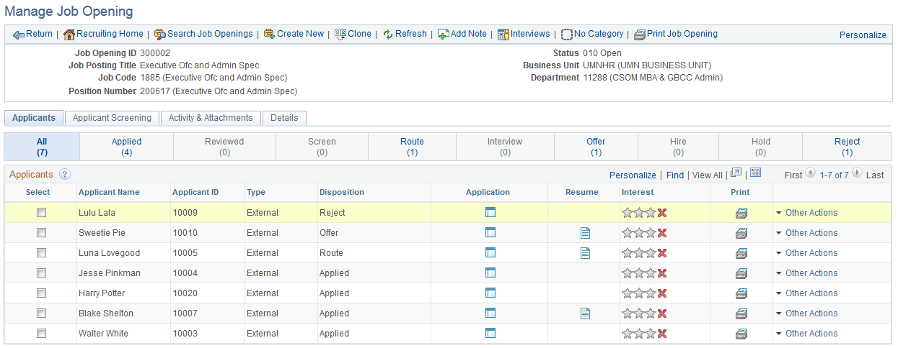

Step 3: Review Application Materials
Applicants have the ability to submit application materials, which may include attachments such as a resume, cover letter, or additional information.

You can click on the Application Icon to view materials:
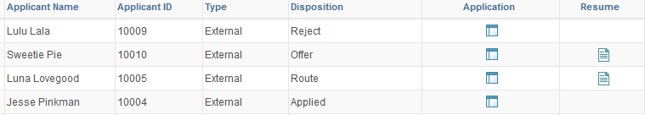
Clicking on the application will bring up the information that an applicant submitted about themselves. This will open up in a new browser tab or window (depending on your preferences).

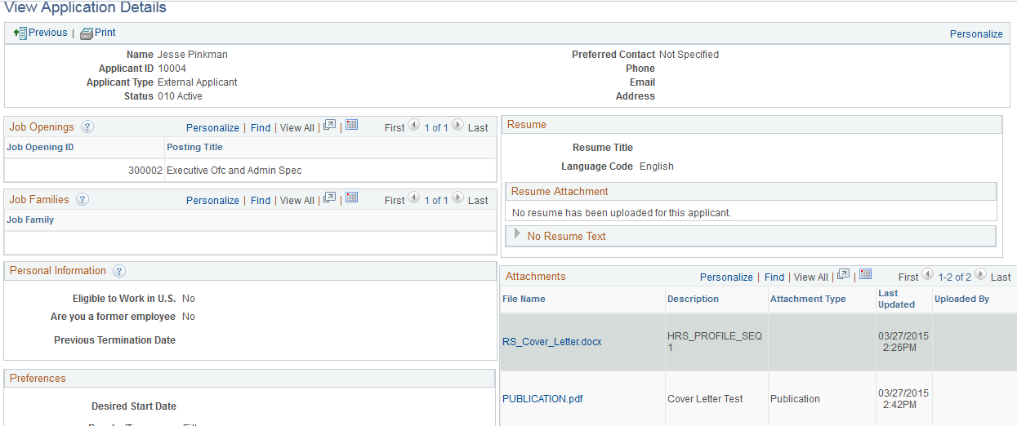
You can download any attachments that the applicant has submitted, or view any work details that the applicant has submitted.

After you have reviewed materials and have made a decision regarding the applicant, you need to update the disposition.

Step 4: Edit Disposition

Click on Other Actions > Recruiting Actions > Edit Disposition
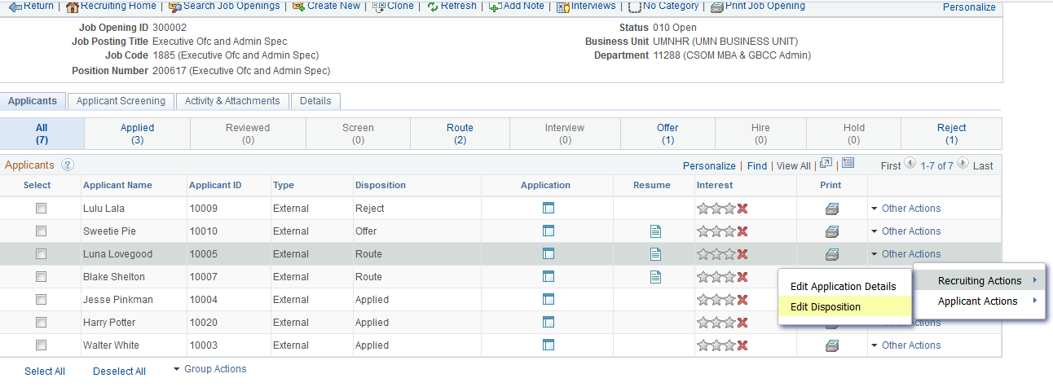

This will bring up the Edit Disposition page. You will have two choices:
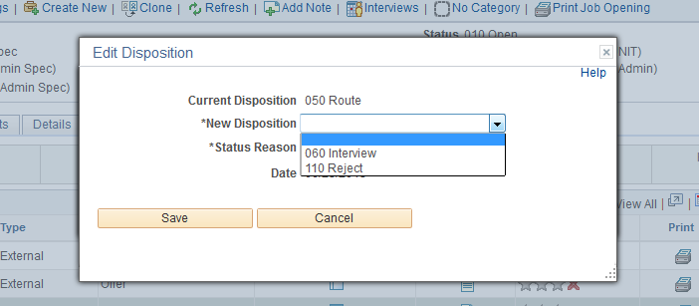

Select the appropriate disposition. In this example, we will reject the applicant. Selecting reject updates the disposition to reject, and you will no longer be able to take Recruiting Actions on this applicant.

Step 5: Send Correspondence
There is no automatic notification sent to an applicant upon the disposition change. Best practice is to send correspondence upon rejecting the applicant, though there are times when a department may choose to correspond with rejected applicants in another manner. At this point, if you are electing to send correspondence to rejected candidates, you can navigate to the send correspondence page with the following navigation:
Other Actions > Applicant Actions > Send Correspondence
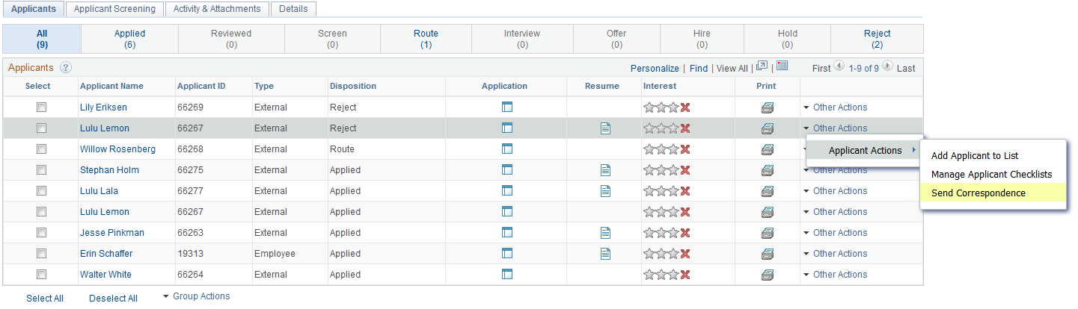
This will take you to the Send Correspondence page.
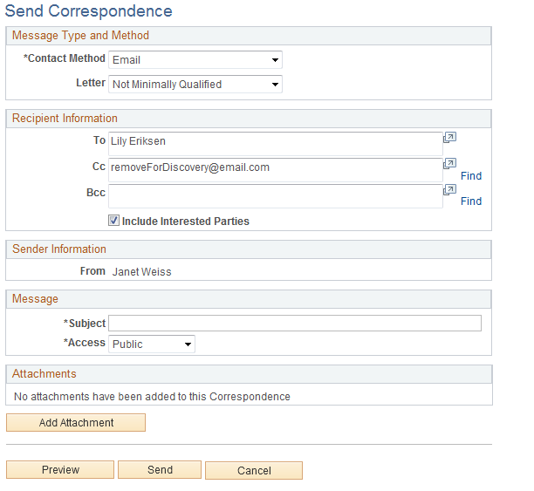
Because this candidate is being rejected for not meeting the minimum qualifications, we have selected the Not Minimally Qualified email.
Enter a Subject and Click Send to send the correspondence.
Note: Now that the candidate has been rejected, you can not bring the applicant back to an active disposition. If you reject an applicant in error, please contact central Recruiting staff to update the disposition.

Interview Process
If you updated the disposition of the applicant to Interview, instead of Reject, this signifies that you have interviewed or will be interviewing the applicant. Interviews may be scheduled internally in the Recruiting system or via your own calendaring method. If you would like to schedule the interview in the system, you will need to work with your Unit Recruiter to schedule the interview. This can be done in the system, so that the Manager will not have to leave to go to their email. Alternately, you could email or call your Recruiter directly for assistance with this process.
Forward Applicant

Other Actions > Applicant Actions > Forward Applicant

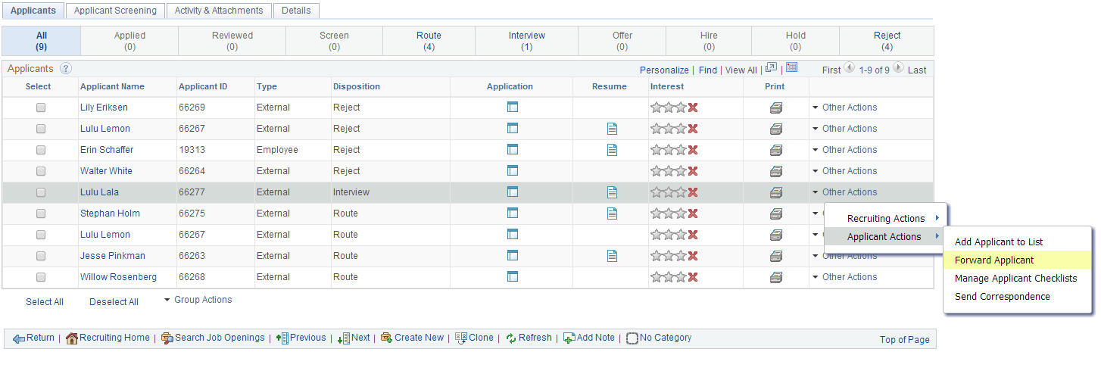
The Forward Applicant page displays:
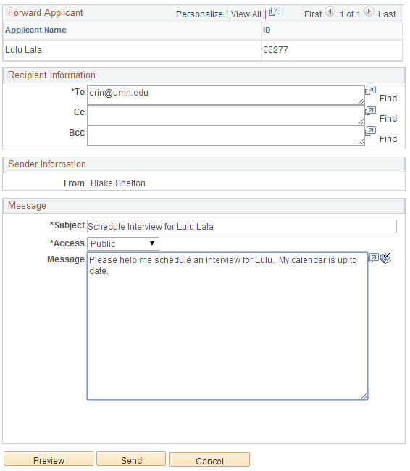

Enter the required information, and click Send. This will generate an email to the Recruiter to help set up the interview.
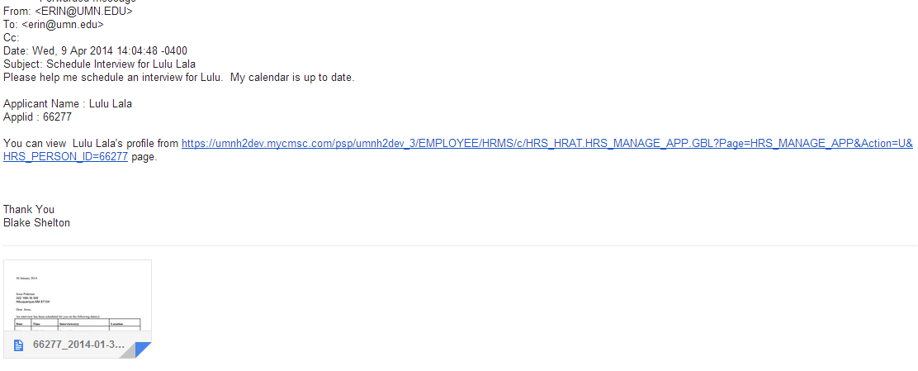

If the interview is scheduled in Recruiting, you can access the information on your interview calendar:
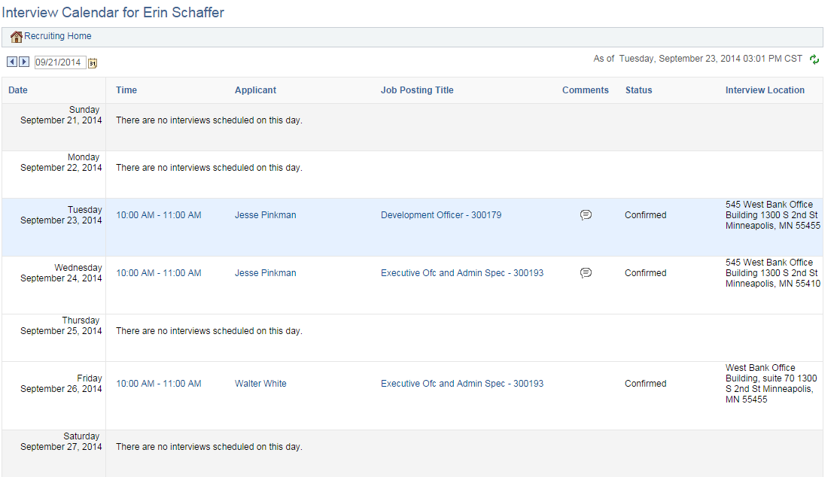

If comments have been added, the comments icon displays.

What Next?
After the interview process is over (this may include multiple rounds of interviews), you will repeat the process of rejecting those applicants who are no longer in consideration. When you are ready to make an offer, please refer to the Offer and Prepare for Hire Business Process Guide.

3.3 Applicant Actions
Applicant actions are those actions that are specific to the applicant, and have no relationship to the job opening. Applicant actions will be available for all applicants, even those that you have rejected:
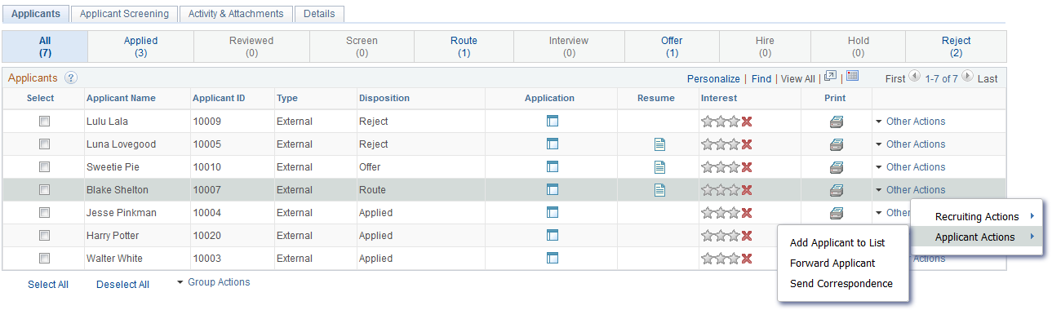

Add Applicant to List allows you to quickly add an applicant to a new or existing list. We will discuss this further below.

Forward Applicant may be used to forward the applicant materials for any number of reasons. We discussed using this to help track applicants that you would like to interview, but there may be other business reasons for using this functionality, as well.

Send Correspondence
Clicking this link will take you to the Send Correspondence page, as discussed earlier. You may send correspondence at any time, not just when you are rejecting an applicant.

You have the ability to send two types of correspondence to an applicant.
1. Pre-populated template correspondence
2. Ad-hoc correspondence

Template Correspondence
To send template correspondence, select a Letter from the drop down menu.
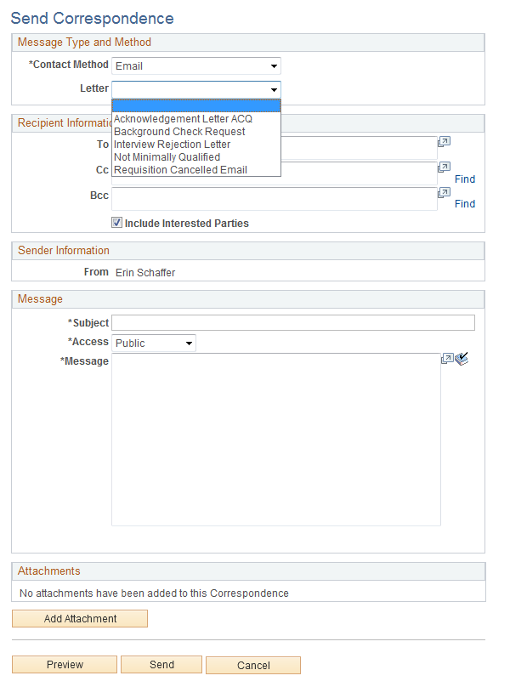
Note: While the system says “Letter”, all correspondence is sent as emails to an applicant.

Acknowledgement Letter is a letter acknowledging that the applicant has applied for a specific vacancy and that their materials will be reviewed. There is an automatic notification that generates for an applicant, so this would be if you would like to send correspondence out in addition to that.

Background Check Request: Letter used by Central Recruiting staff after an applicant has accepted an offer for a job.

Interview Rejection Letter: Letter used by unit Recruiters and Hiring Managers if an applicant has been rejected after interviewing for a job opening.

Not Minimally Qualified: Letter used to communicate that an applicant does not meet the qualifications for a vacancy. Used by both Central (CS/LR) and Unit (Faculty/P&A) Recruiting staff.

Requisition Canceled Email: Letter used to communicate that a job opening has been canceled. May be used by any recruiting user.

Ad-hoc Correspondence
To enter ad-hoc correspondence, simply type in the message that you will send to the applicant.
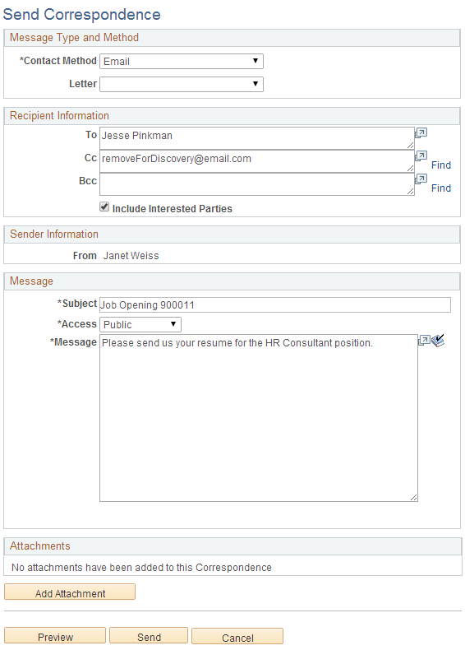

The system will generate a greeting and salutation for you, so you only need to enter the body of the message.

You may preview the correspondence, and see how it will look to the applicant:

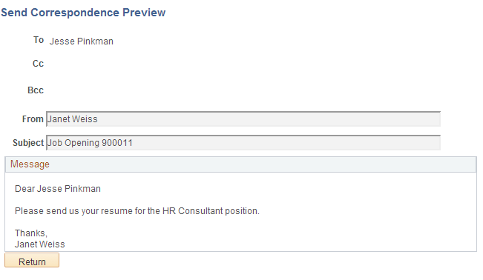

To send either template based or ad-hoc correspondence, click the Send button. This will generate an email to the applicant.

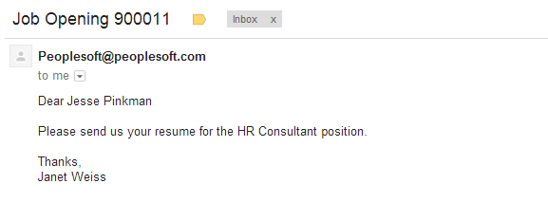

3.4 Group Actions
In addition to performing actions on one row of activity, you also have the ability to perform Group Actions. This functionality appears on the Manage Job Opening page (group actions related to multiple applicants).

To perform Group Actions, you must first select the row(s) that you are interested in applying the action to, as seen below:

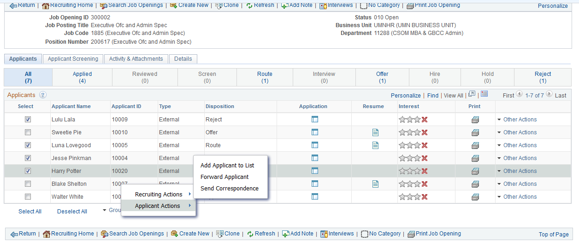
As with Other Actions, Group Actions are comprised of Recruiting Actions and Applicant Actions.

Recruiting Actions are limited for Hiring Manager. You will see options, but may not have the authority to perform them on these applicants.

The Applicant Actions available to you will be Add Applicant to List, Forward Applicant, Send Correspondence. You may perform these actions for multiple applicants at one time.

4.0 Create and Manage Applicant List
Hiring Managers have the ability to create Applicant Lists to help with the Recruiting Process. Lists are used to keep track of applicants who many not apply to many openings, but who you want to keep on your radar for other vacancies.

My Applicant Lists is a delivered pagelet on the Recruiting Home. Users can access public and private lists by clicking on the links in the pagelet.

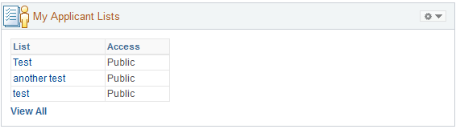

Clicking View All will take the user to the Applicant List page:

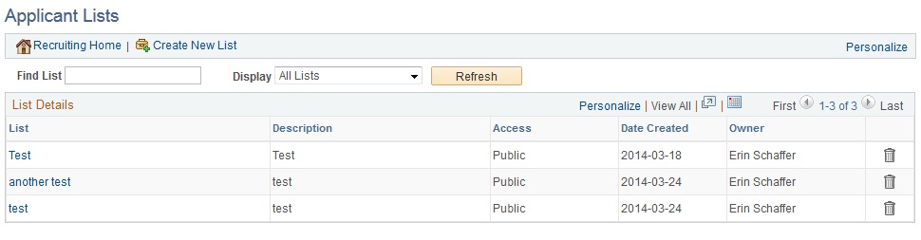

You can create a list from this page, though most users will do so from the Job Opening page.

Process Steps

Step 1: Navigate to Recruiting Home

Main Menu > Recruiting > Recruiting Home

Step 2: Click on Job Opening in “My Job Openings”

In this example, we will click on 900010.
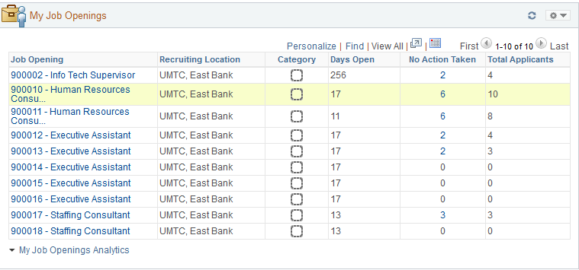

The Manage Job Openings page displays.

Step 3: Select Applicants and navigate to Group Actions

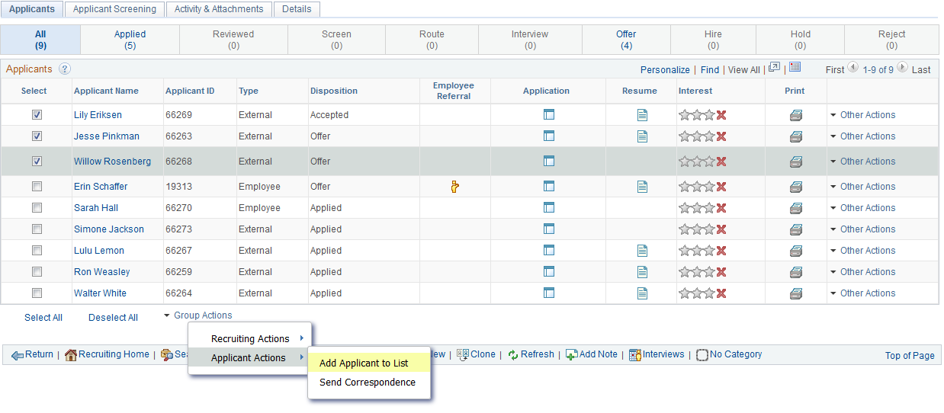

Navigate to: Group Actions > Applicant Actions > Add Applicant to List

The Add to Applicant List page displays:

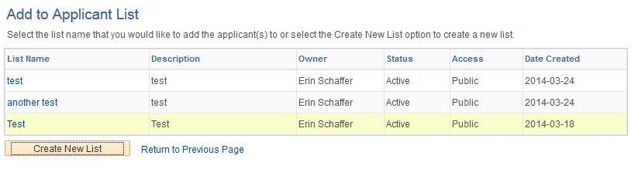

You could select a list that exists, but in this example, we will create a new list.

Step 4: Create New List

Click the Create New List button. Enter the required information (List Name, Status) and click Save.
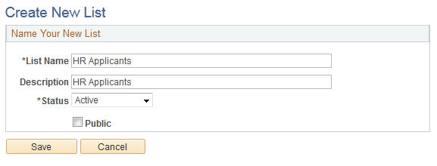
Note: Public lists are viewable to ALL Recruiting users, so it is best to leave lists as private.

Step 5: Manage Applicant List

You will be taken to the Manage Applicant List page upon save.
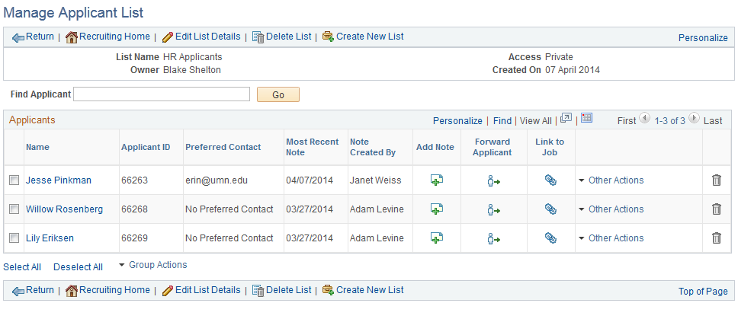
From here, you can perform other actions on an applicant, edit the list details, or create a new list.

Expected Outcomes
Using this Business Process Guide, you should be able to obtain the following results:
- Understand how to navigate through the Recruiting module
- Understand how to manage job openings
- Gain the knowledge to complete Recruiting activities for your job openings
- Understand Applicant Tracking Requirements
- Learn how to create and manage applicant lists

